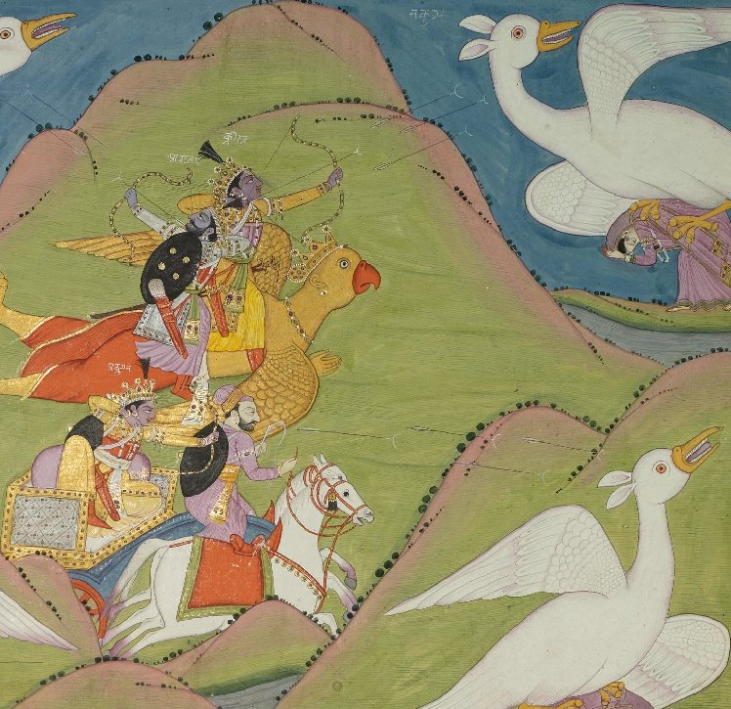

Character: Pradyumna
Committee: Mahabharata Crisis
Delegate: Vivian Chen, Heritage High School

Character Position
As the son of Lord Krishna, Pradyumna is aligned with Krishna and his loyalty to the Pandavas. Due to Lord Krishna’s grace when I returned to him after a lifetime of separation, I am confident that Krishna’s judgement is irrefutable. In addition, the Pandava family is merciful, devout, and worthy of the divine intervention. The Pandavas deserve another chance after losing everything in a simple, foolish game of Parcheesi. Naturally, I would not support the breakout of a civil war as I am one of the vyuhas of Vishnu the preserver and the reincarnation of the god of love, Kamdeva. However, if the war expands beyond my control, I will come to the aid of the Pandava demi-gods with my father Krishna.
Situation at Hand
Currently, the Pandavas and Kauravas are on the brink of war. From a game of Parcheesi, the Pandavas were exiled for thirteen years and have now returned to regain the kingdom. However, the Kauravas refuse to relinquish their land to the Pandavas. After the wedding of Arjuna and Abhimanyu following the return of the Pandavas from exile, the Pandavas began to devise a war strategy to regain their land. Coupled by the Kauravas kidnapping a key Pandava ally by trickery, the uncle of the Pandava twins, the Pandavas are infuriated as ever. Outraged at the Kaurava’s deception and mockery, the outbreak of war seemed unavoidable to the Pandavas. A compromise is needed in order to avoid this war.
Previously Attempted Solutions
Duryodhan initiated two dice games with the Pandavas in order to regain Indraprastha. Representing the Pandavas, Yudhishthir lost both rounds of the dice game and was sentenced to thirteen years of exile. If the Pandavas were to be seen during this exile, their sentence would be doubled. This game played to the Kauravas’ favor and secured them them Indraprastha and Hastinapur. After the thirteen-year exile, the Pandavas sent emissaries to Hastinapur to retake the throne. In addition, Krishna embarked on peace mission to compromise with the Kauravas. However, both attempts failed. Duryodhan, the eldest son of the Kauravas, refused to relinquish any lands to the Pandavas including the five villages Lord Krishna had outlined in the peace mission. Neither the Kauravas’ actions nor the Pandavas’ actions resulted in undisputed transfer of power; both families’ actions left controversial residue which ultimately accumulated into a breakout of war.
Potential Solutions
To avoid the breakout of war, the Devas can use dharma and karma to punish those who are doing wrong. For example, the Devas can inflict punitive measures on the perpetrators/advancers of the war in order to mute their actions. As the main proponent of the war, Duryodhana must be obstructed in war preparation and propaganda efforts by physical crippling or emotional harm. This can be done by injuring the ones that he loves, such as his spouse Bhanumati. In addition, a critical moment in the initiation of the war was Arjuna’s emotional fluctuation after seeing his great-grandfather Bheeshm, his teachers Kripa and Drona, and his brothers the Kauravas. The Devas can take advantage of this situation to intensify his regret in order to prevent the war. However, Krishna must be silenced at this time as he was the deity who emphasized the impermanence of life, stressed the importance of doing one’s duty, and persuaded Arjuna to resume with his original plans. In order to prevent the Pandavas’ exile and therefore prevent the land conflict, the devas can take measures to punish Duryodhana after his unfair advantage to the dice game. The Devas can also use their divine powers to warn the Pandavas of the Kauravas’ attempt to deceive them with the dice game.
Using divine intervention, the Devas can transform into their mortal forms to initiate negotiations. The land issue can be solved by potentially diving Indraprastha into two and assigning the land to the Kauravas and Pandavas. Furthermore, the Devas can negotiate with the Pandavas and the Kauravas. For example, they can grant nirvana and liberation from samsara to the family that decides to relinquish property rights to Indraprastha.
Course of Actions
During the committee session, I will align myself with the Devas and use divine intervention to elevate/diminish individuals’ positions and powers to avoid the war. To do this, my main goal will be to emotionally/physically cripple or exile Duryodhana, the main proponent of the war. This will result in the eradication of his influence, thereby avoiding the war, eliminating the dice game, and preserving the Pandavas’ possession of Indraprastha. In addition, I will work with the Devas to restore peace in the land of Indraprastha. If possible, I will reincarnate myself into a human to advance the land negotiations. If this is not possible, I will remain as a god in order to restore peace and preferably restore Indraprastha into the hands of the Pandavas.

Works Cited
Basu, Anindita. “Mahabharata.” Ancient History Encyclopedia, VOX, 25 Aug. 2016, www.ancient.eu/Mahabharata/.
DigitalCavalry. “Krishna's Son Pradyumna.” I Yadav, iyadav.com/krishnas-son-pradyumna/.
“Pradyumna.” Wikipedia, Wikimedia Foundation, 24 Jan. 2018, en.wikipedia.org/wiki/Pradyumna.
Shmoop Editorial Team. “The Mahabharata Video.” Shmoop, Shmoop University, 11 Nov. 2008, www.shmoop.com/video/the-mahabharata.

Indraprastha- the land
Hastinapur- the thone
Kaurava
Pandavas- Exiled, demigods
Duryodhan- Kaurava who wants war, eldest brother
Arjuna- Pandava who almost refused to go to war because he was too emotional, skilled archer
Draupadi- Husband of many Pandavas, essentially caused the exile
Yudhishthir- Guy who played the dice game with the Kauravas
Shakuni- Master Parcheesi player (Kaurava)

